Name: ____________________________________________________________________________________
Simple Machine Home Survey
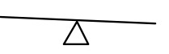  Lever | 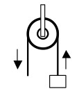  Pulley | 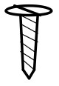  Screw | 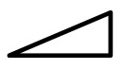  Inclined Plane | 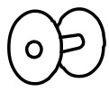  Wheel and Axel | Wedge

